Step 1:

Log in to AWS account

Have downloaded resources ready for yourself

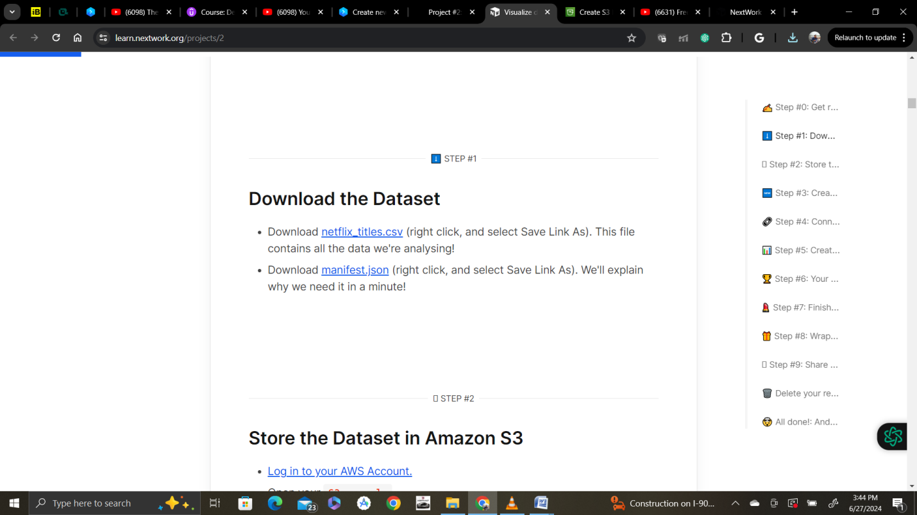

Step 2:

Open S3 and create a bucket

Name bucket as nextwork-quicksight-project-Krishna802

* Select the Region closest to you.
* Keep the rest of the settings as default, and select Create bucket.
* Upload the CSV file and the manifest.json file into the bucket.
* Copy the S3 URL of your netflix_titles.csv file.

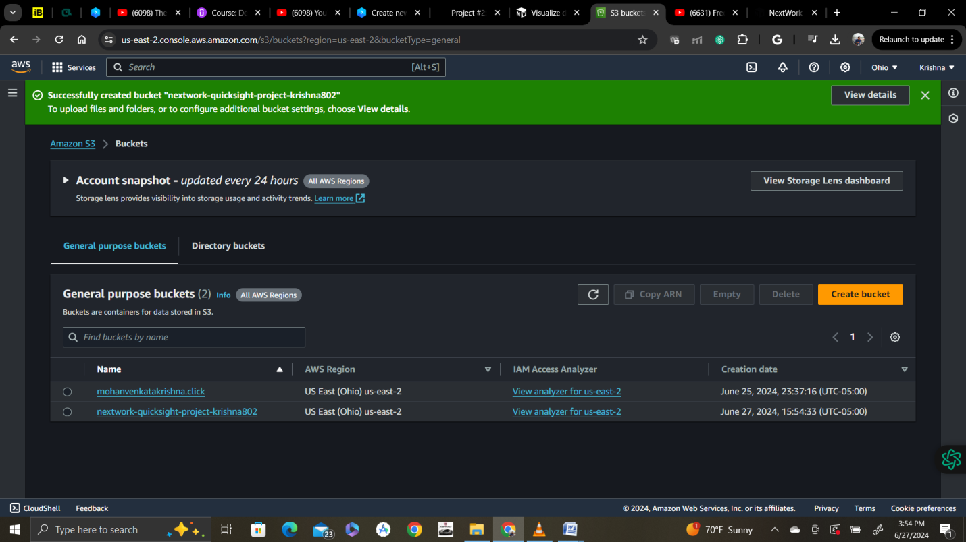

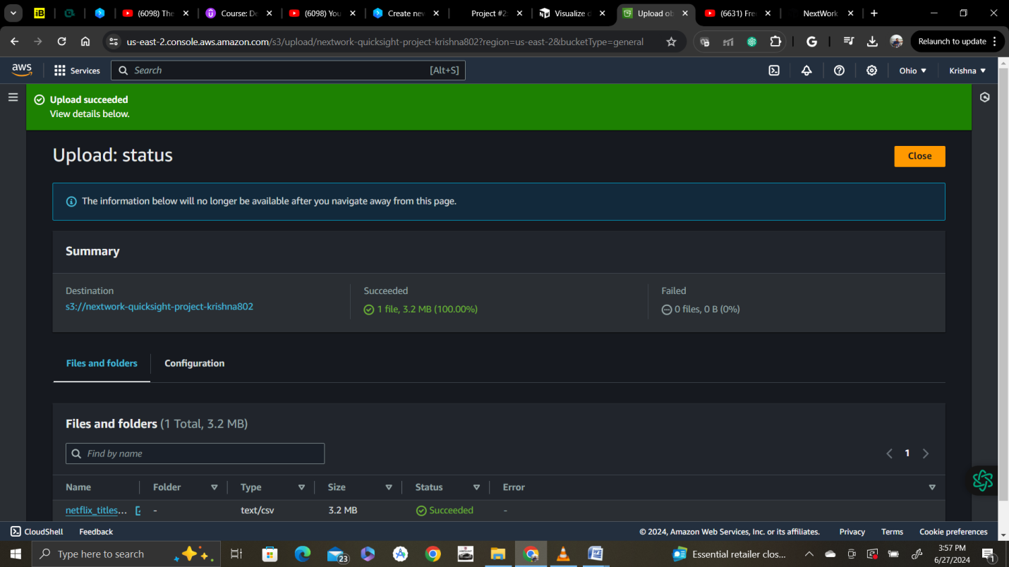

s3://nextwork-quicksight-project-krishna802/netflix_titles.csv

change the URI in the Json file as below:

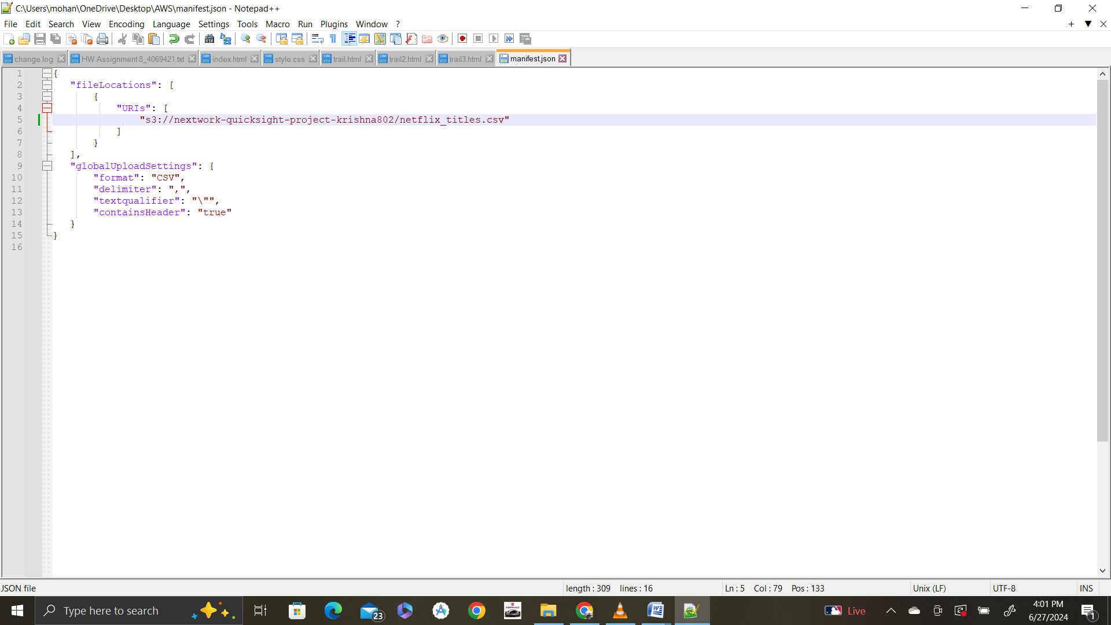

Now upload edited Json file too

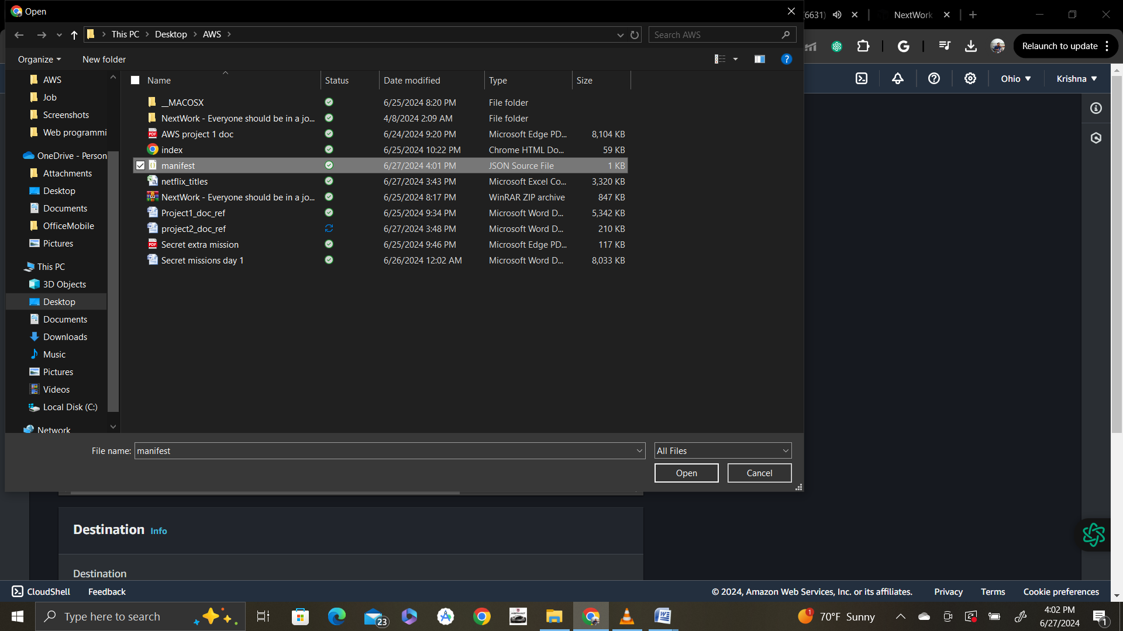

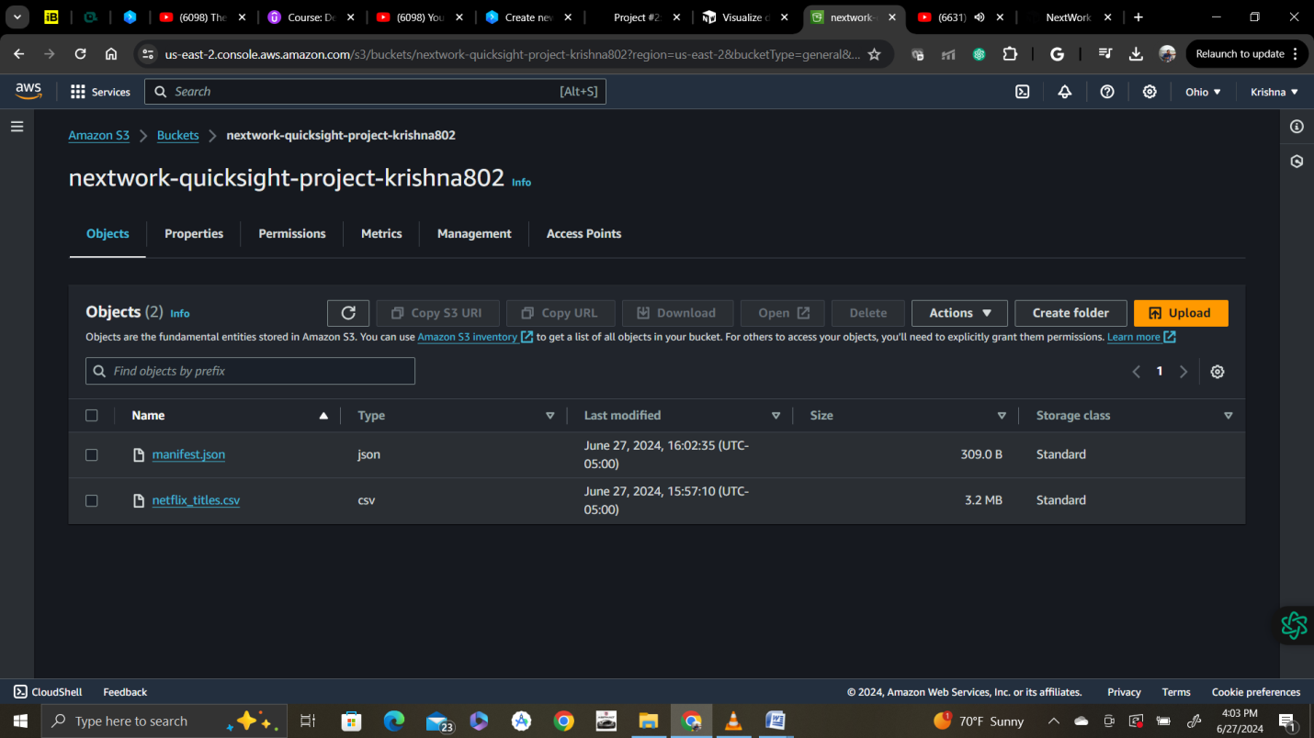

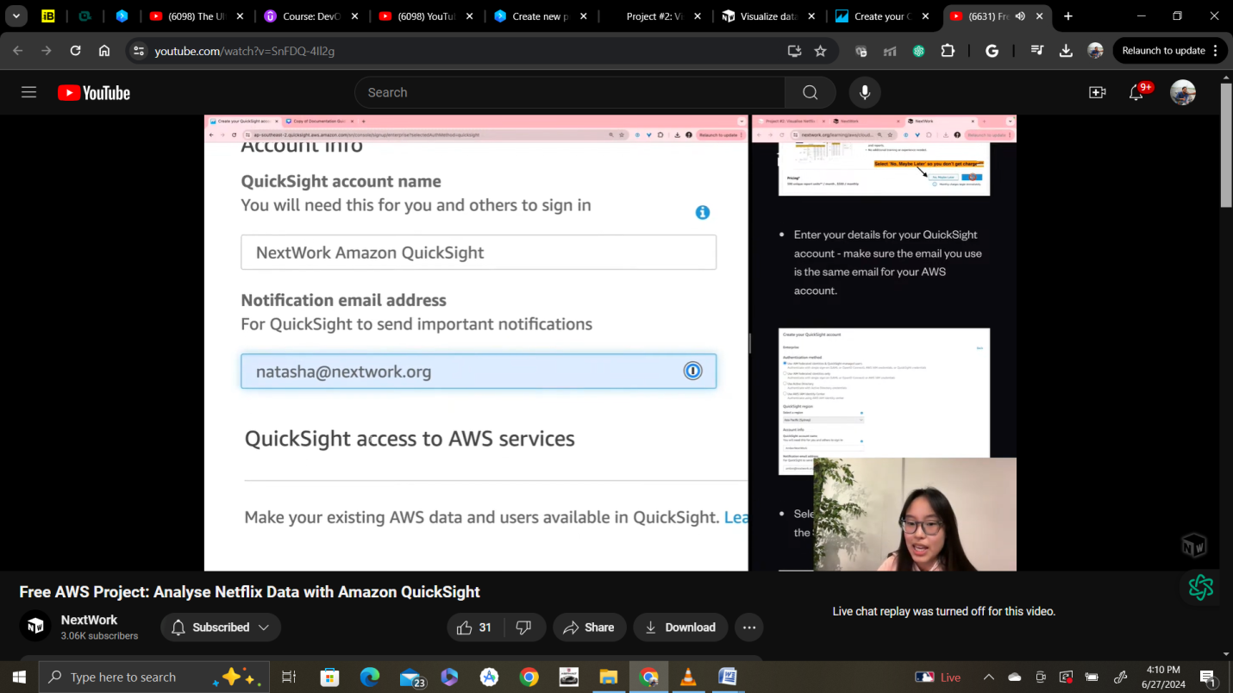

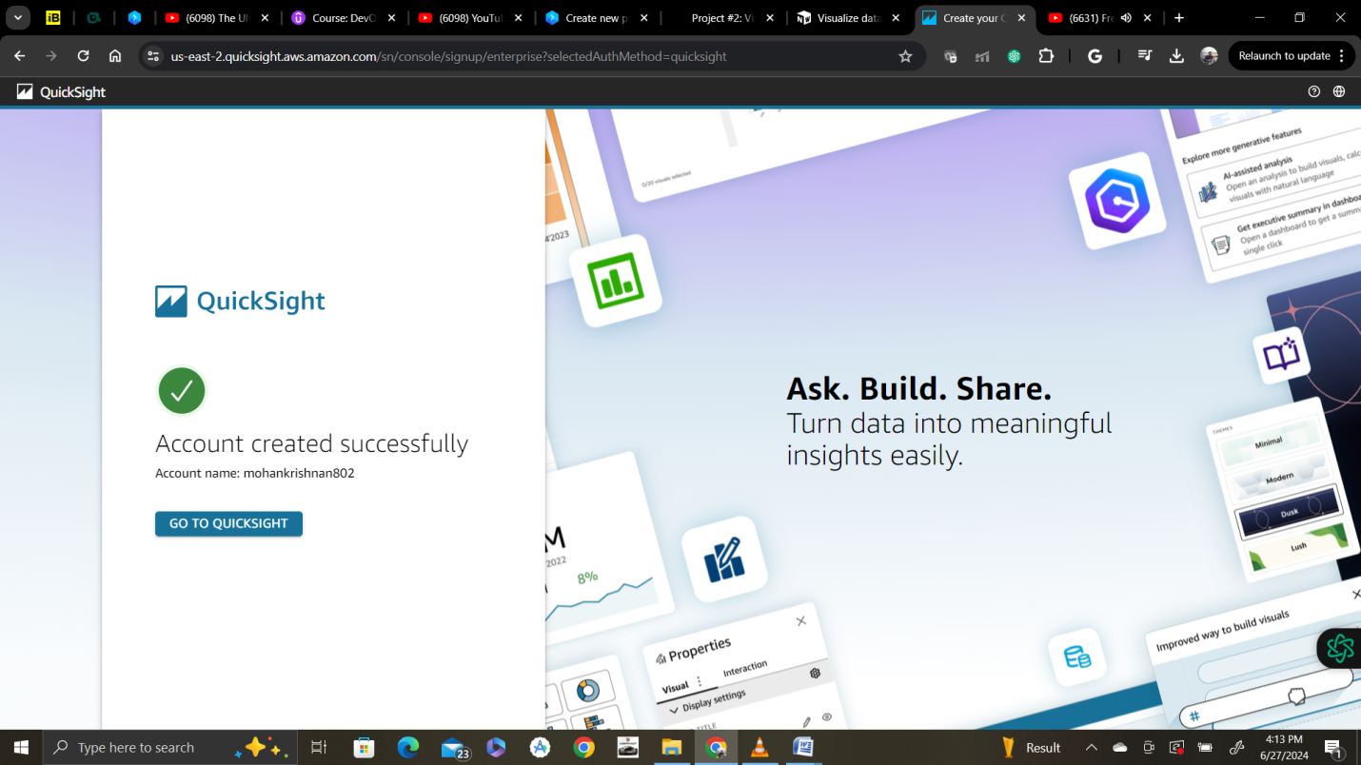

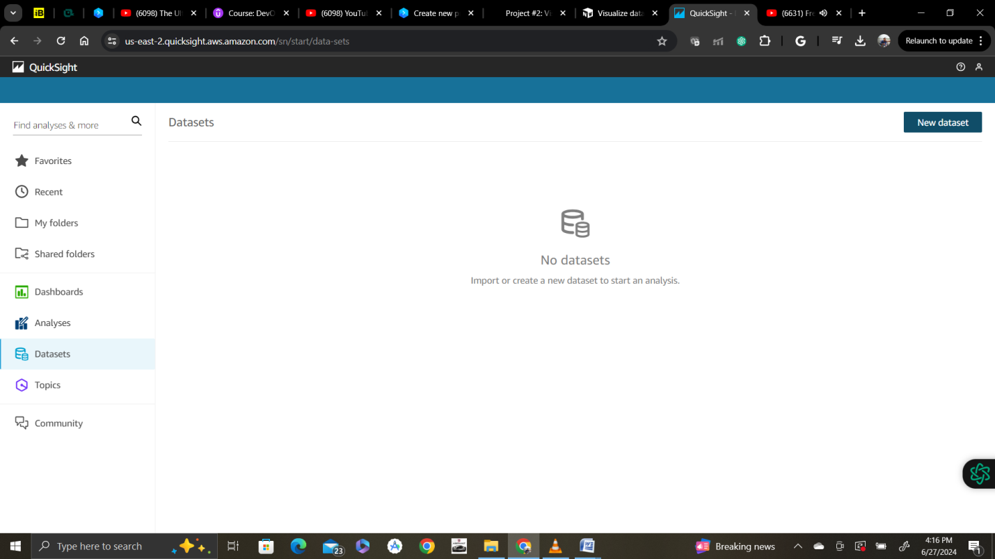

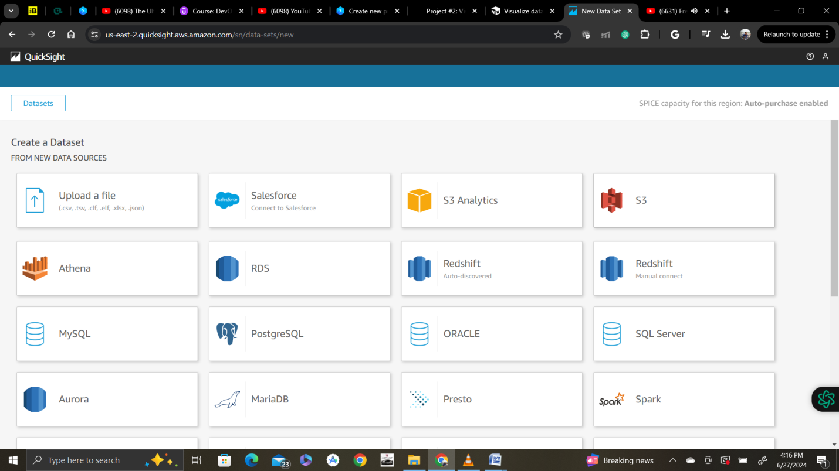

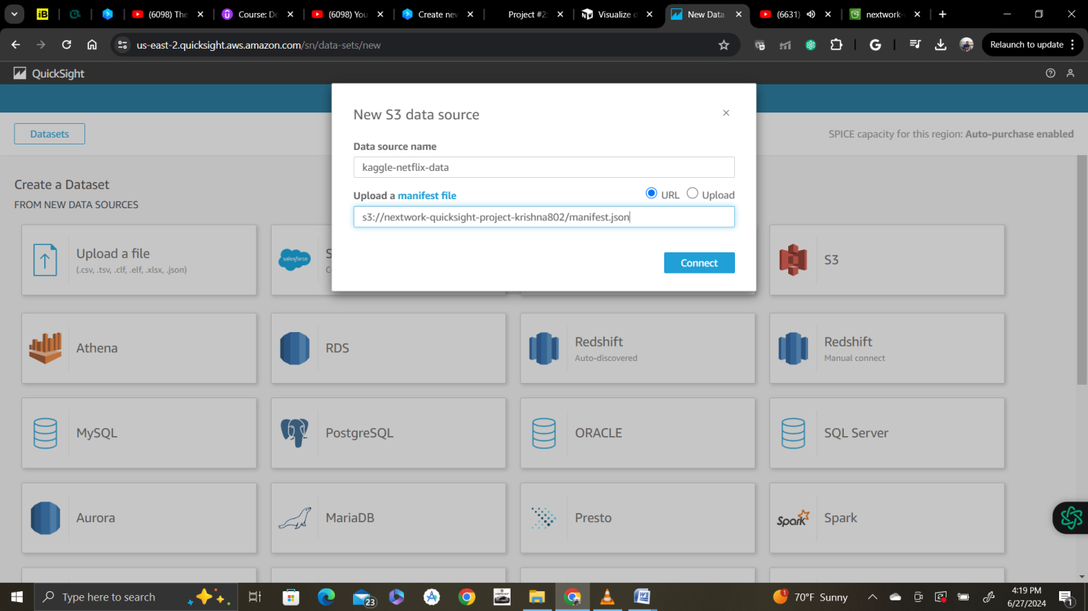

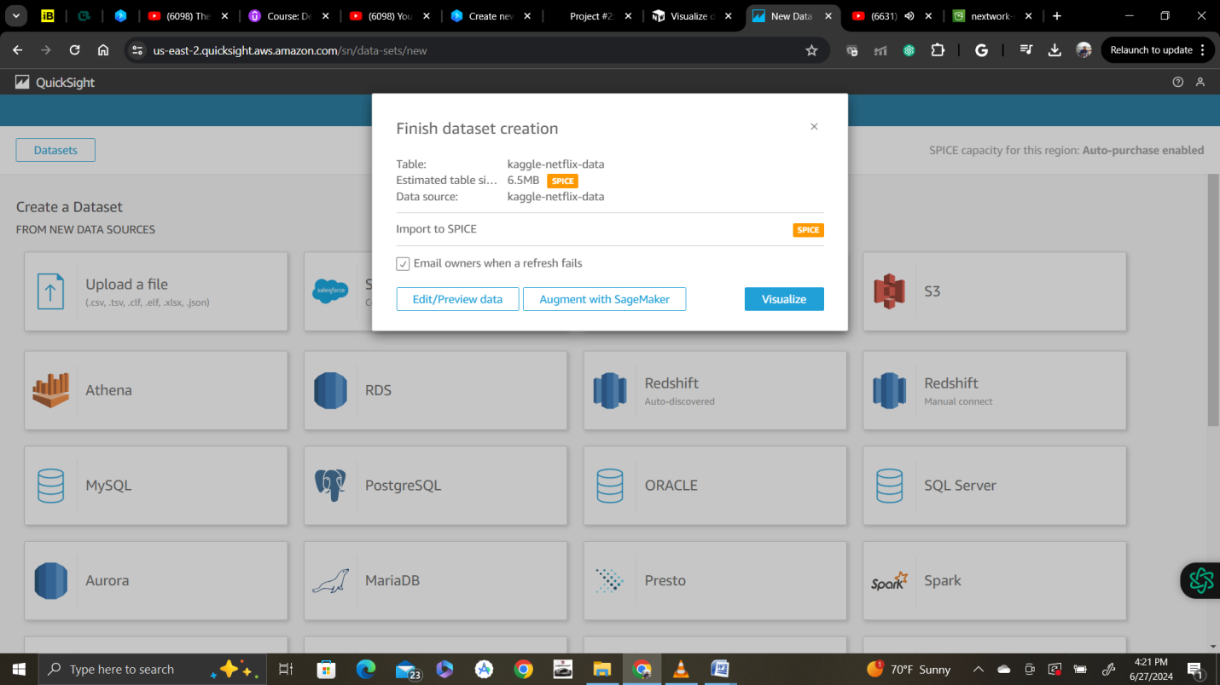

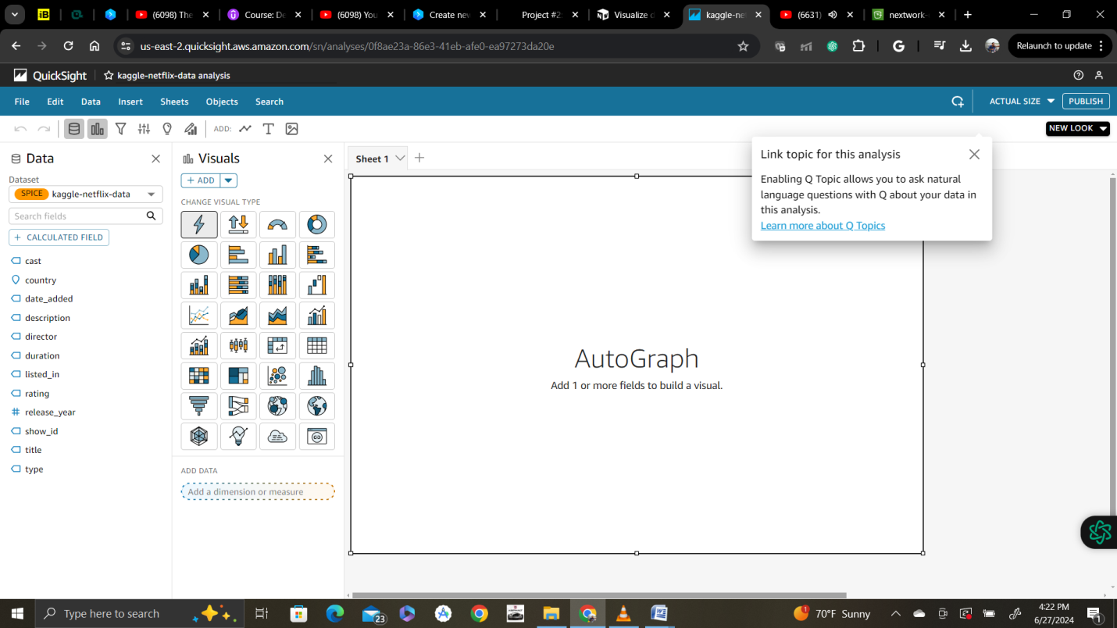

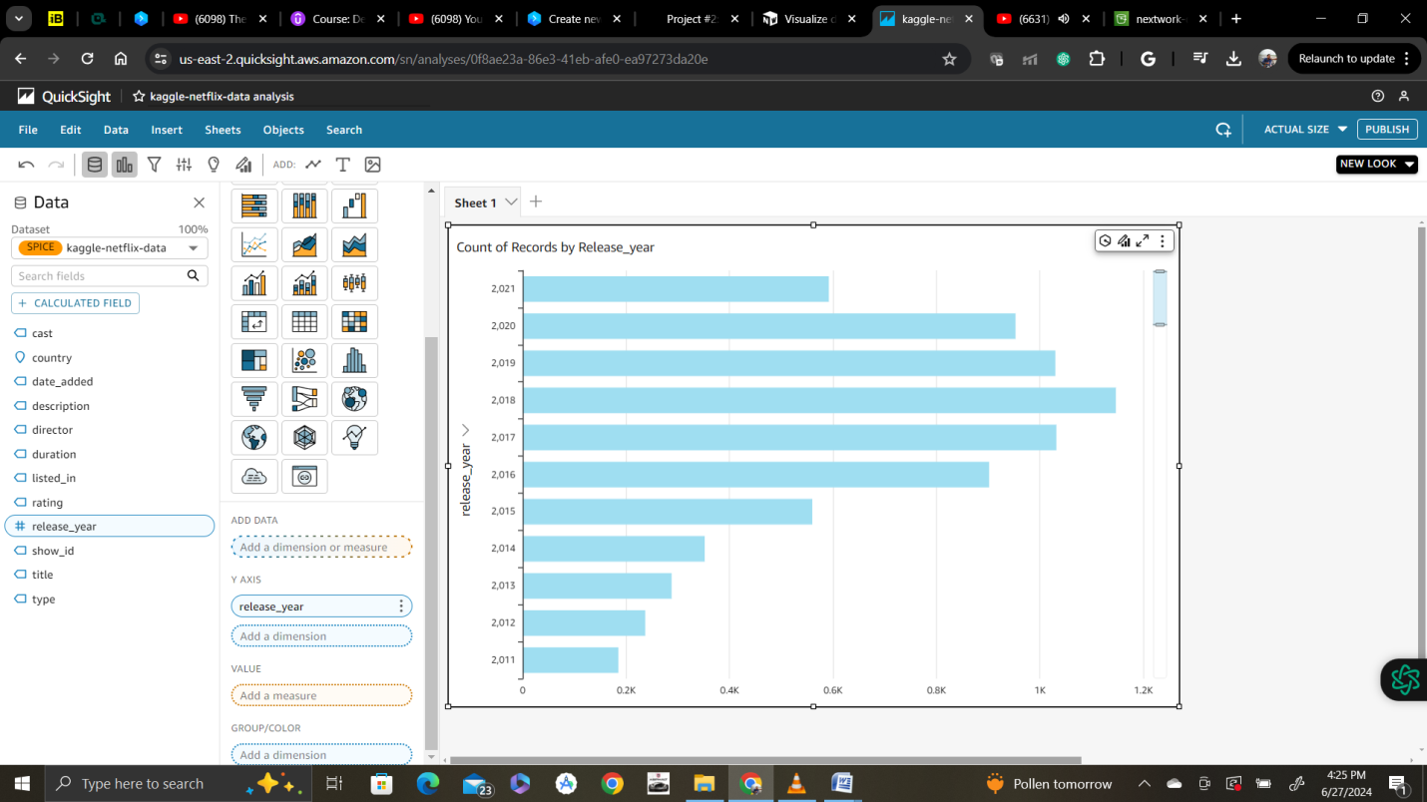

Changed to donut chart the above data

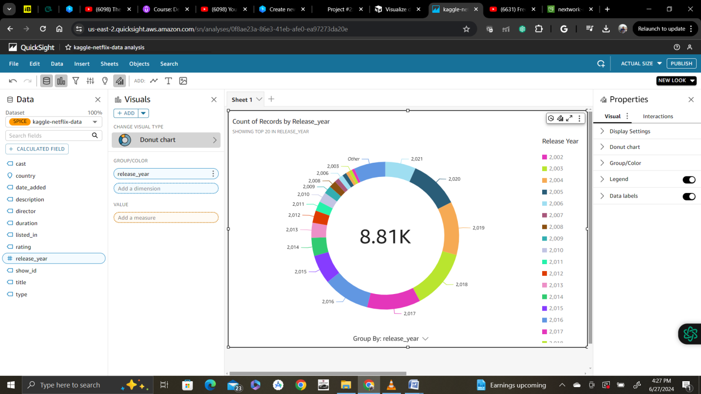

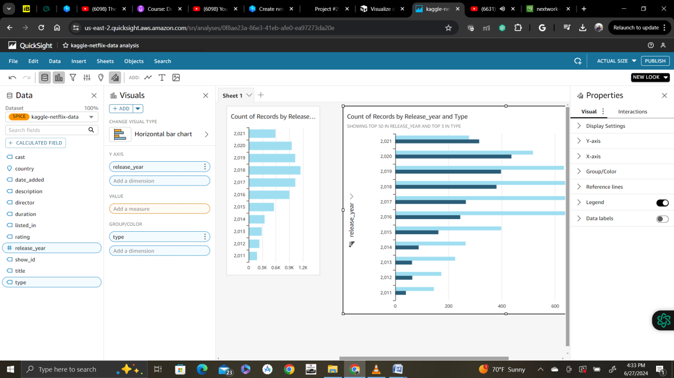

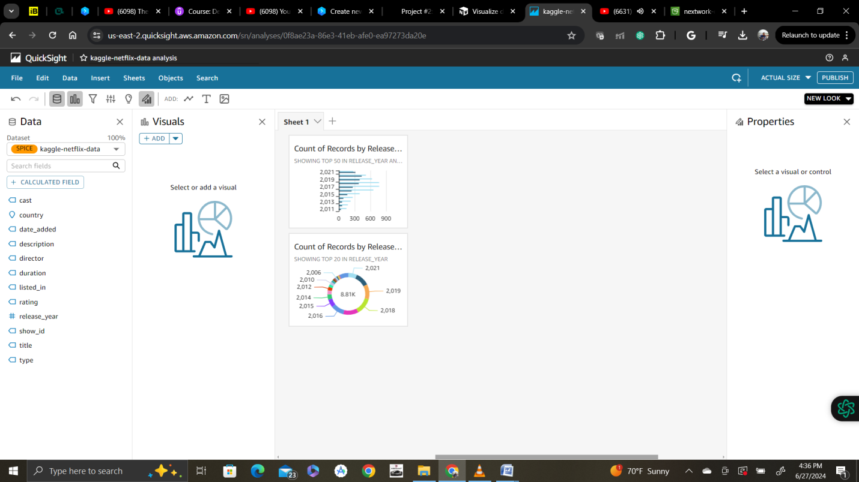

Let's say you've just presented your first two QuickSight charts to Netflix's data team lead, and they're impressed and would like to see what else you can find! They give you a brief with 5 questions that you should be able to answer with QuickSight.

Continue adding to your dashboard (make sure not to replace your existing graph for each task). Some of these are more advanced requests than others, but give it a go!

💡 If you get stuck, the step by step instructions are under these questions.

* [Add a new chart instead of replacing the current one!]  
  **"I quite like the breakdown of TV shows/movies for each release year. Would it be possible to stack movies and TV shows in the same row, so you can visualise the % of each?"**

This is how to be duplicated and visualized new chart selection

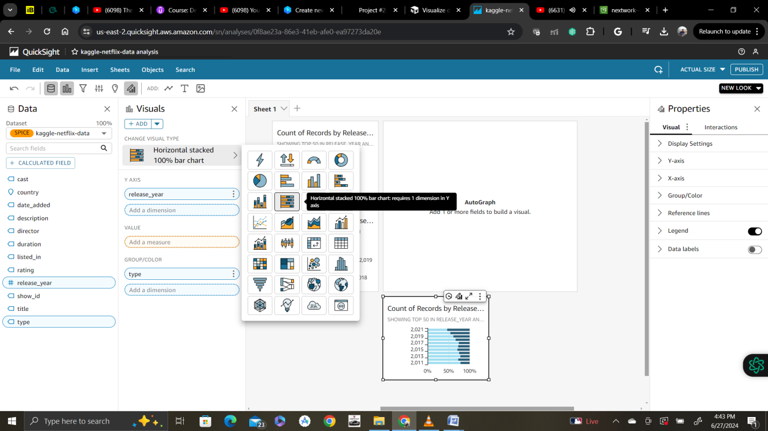

[Add a new chart instead of replacing the current one!]  
**"Now can you show me the same thing in a table? i.e. please show me the number of movies vs TV shows per release year in a table."**

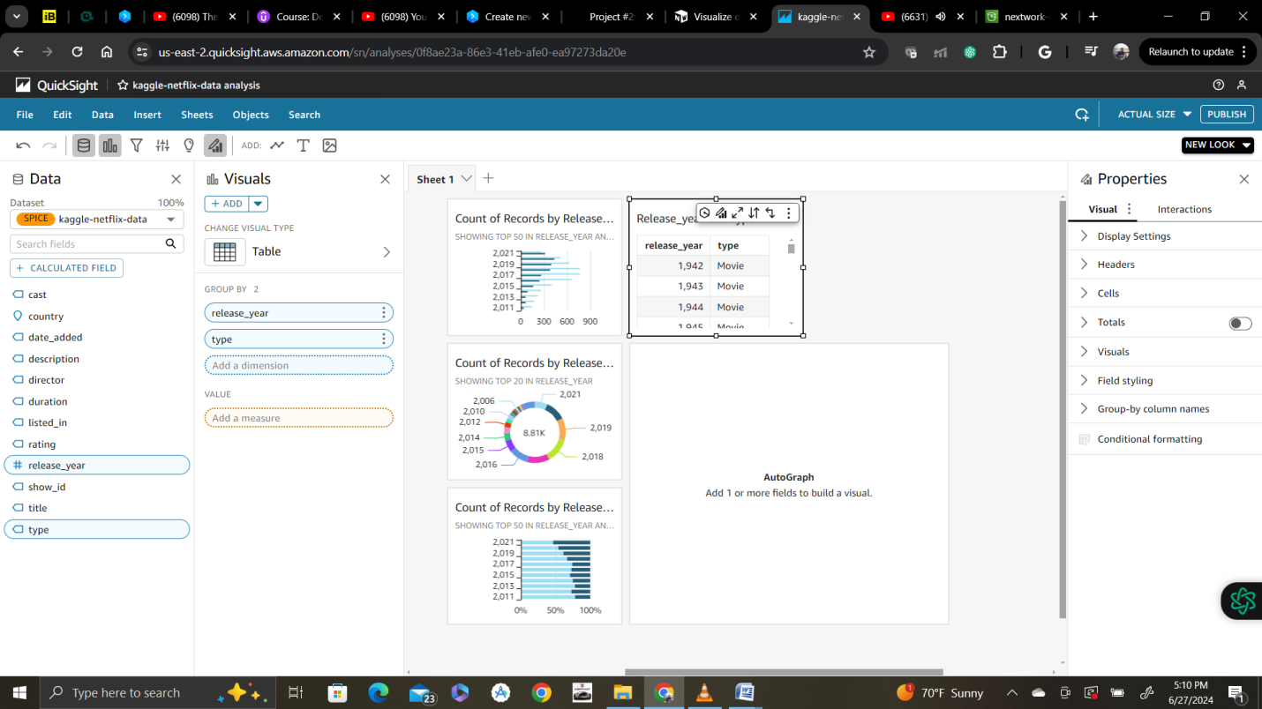

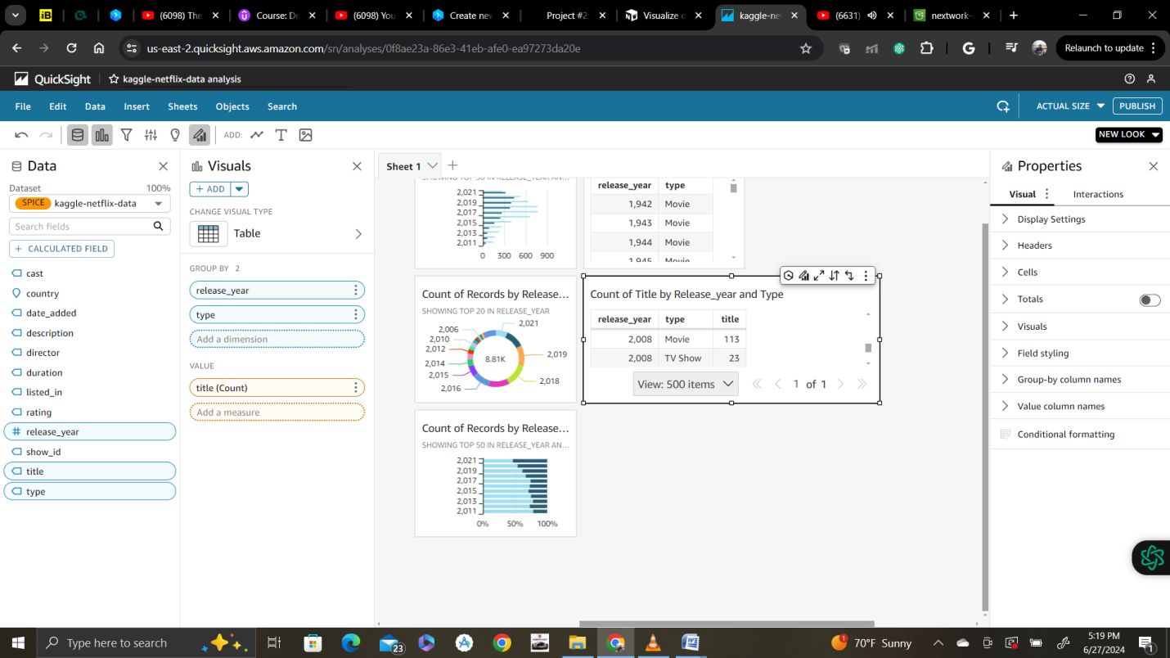

* [Add a new chart instead of replacing the current one!]  
  **"On what day did Netflix add the largest number of movies/TV shows to their catalogue?"** ‍

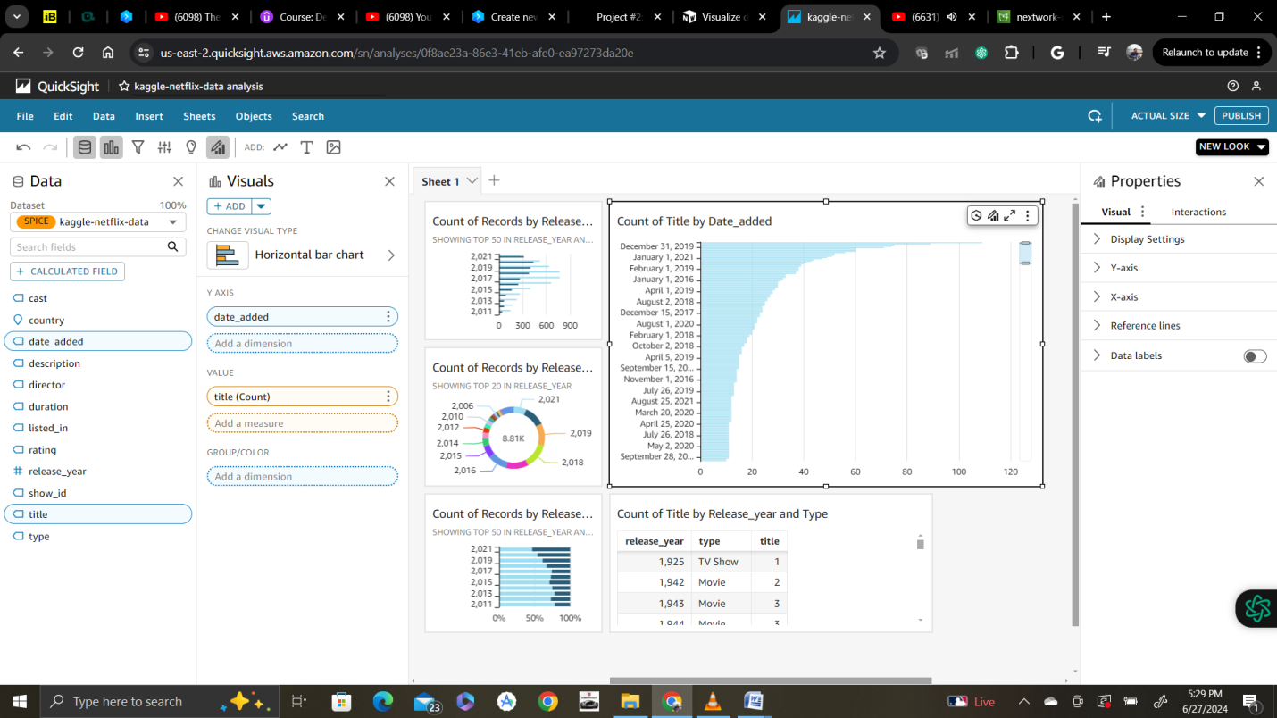

* [Add a new chart instead of replacing the current one!]  
  **"Of the TV shows and movies featured, how many were listed as 'Action & Adventure', 'TV Comedies', or 'Thrillers'? For simplicity, ignore the TV shows and movies that have multiple listings/categories."**

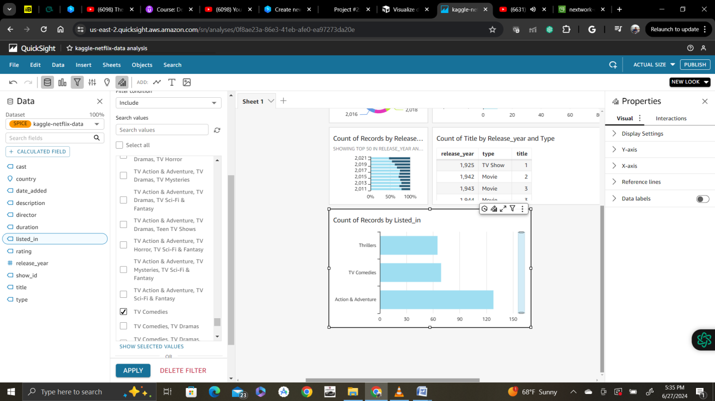

* **"Of the TV shows and movies with the listing 'Action & Adventure', 'TV Comedies', or 'Thrillers', how many were released on 2015 or after?"**

**Add another filter as below for year**

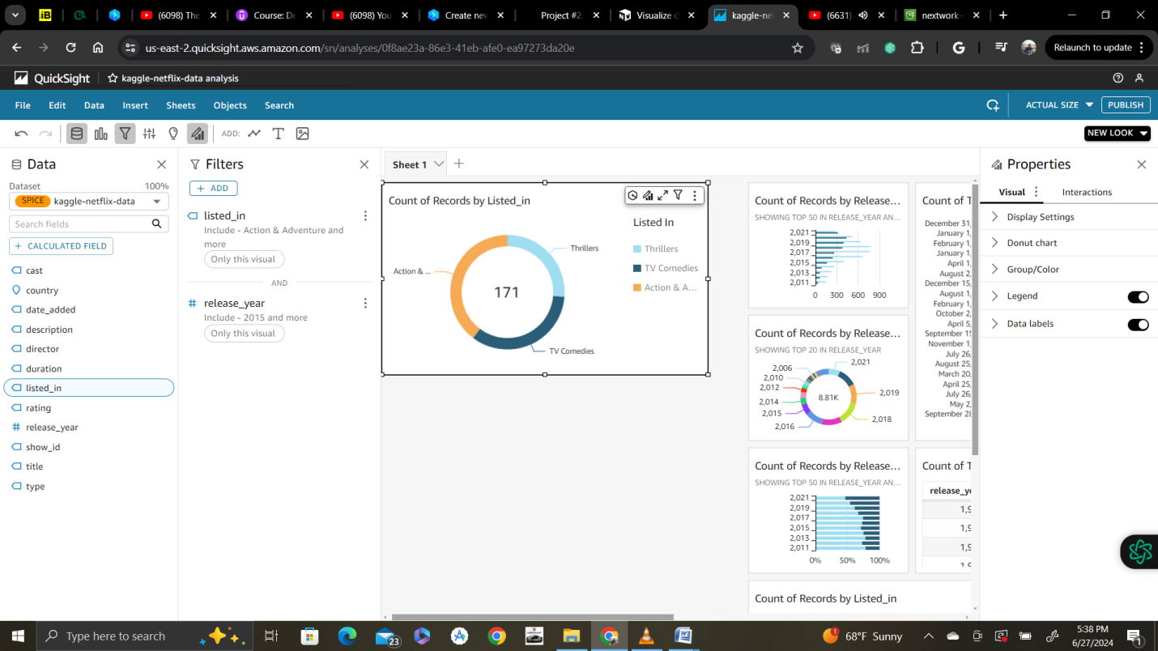

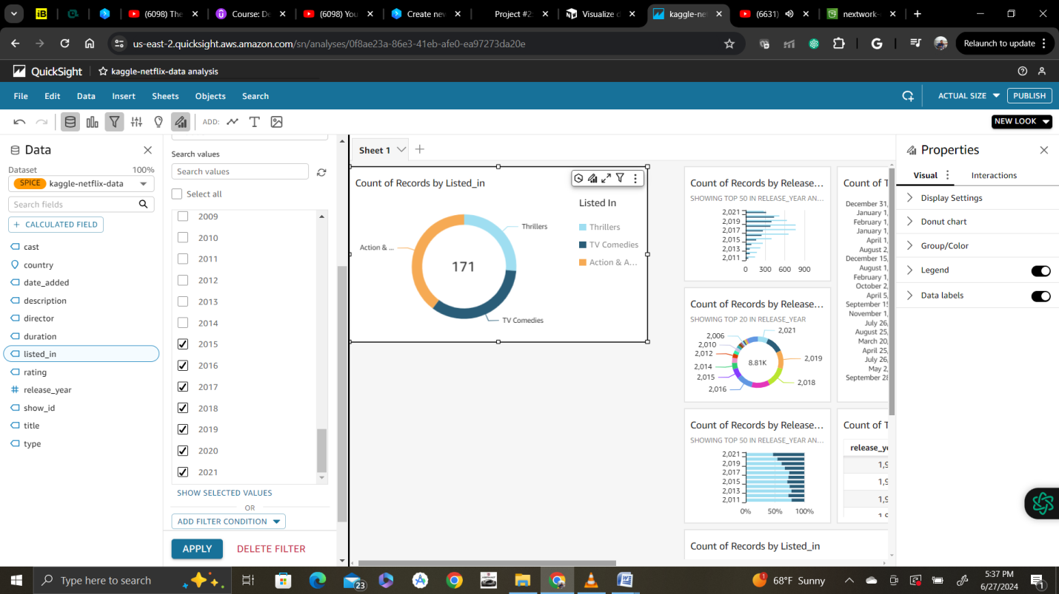

Final dashboards created today:

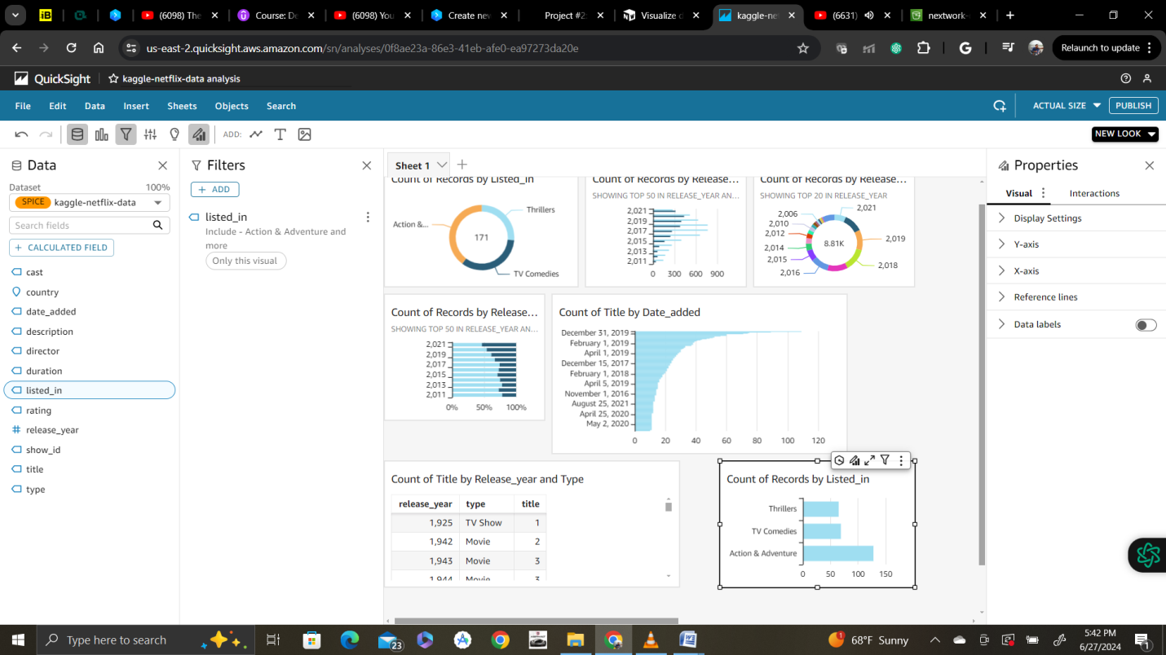

* To round it all off, edit the titles in your charts so that anyone can understand them at a glance.
* Double click on the titles of all the charts you see in front of you.
* This Edit title panel will pop up:

1. # of Movies/TV Shows by Release Year

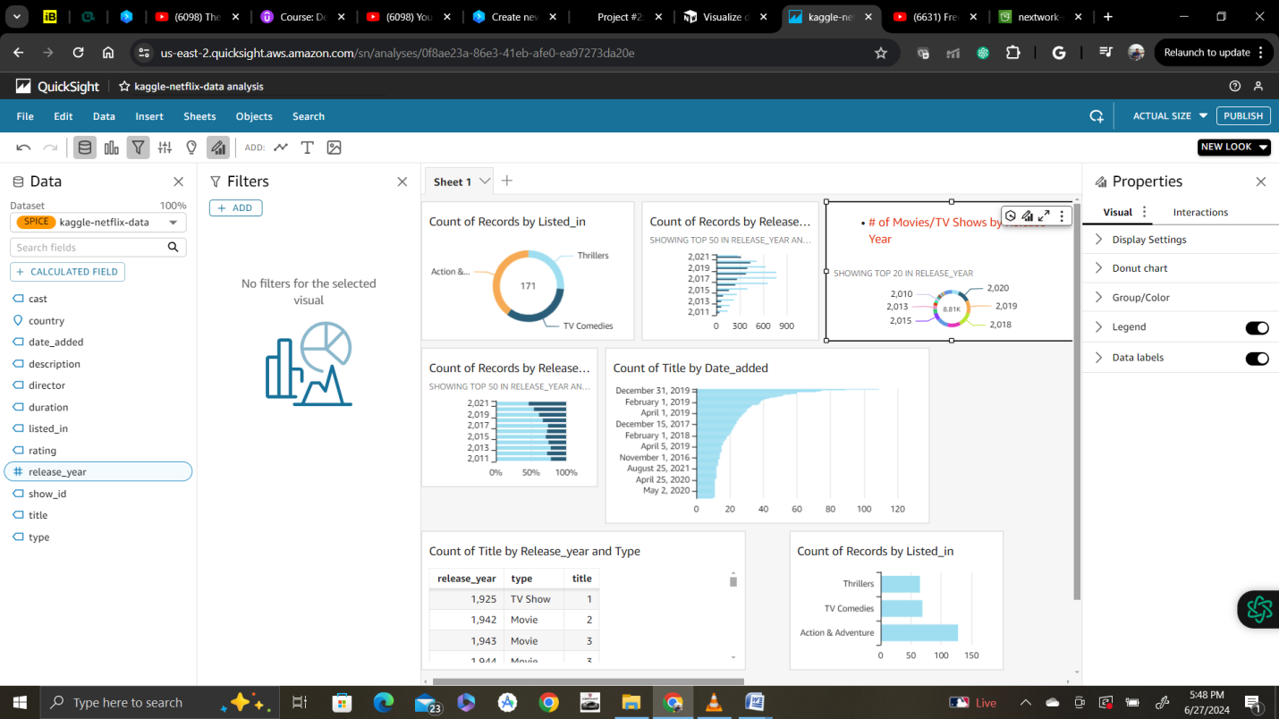

2. # of Movies vs TV Shows by Release Year

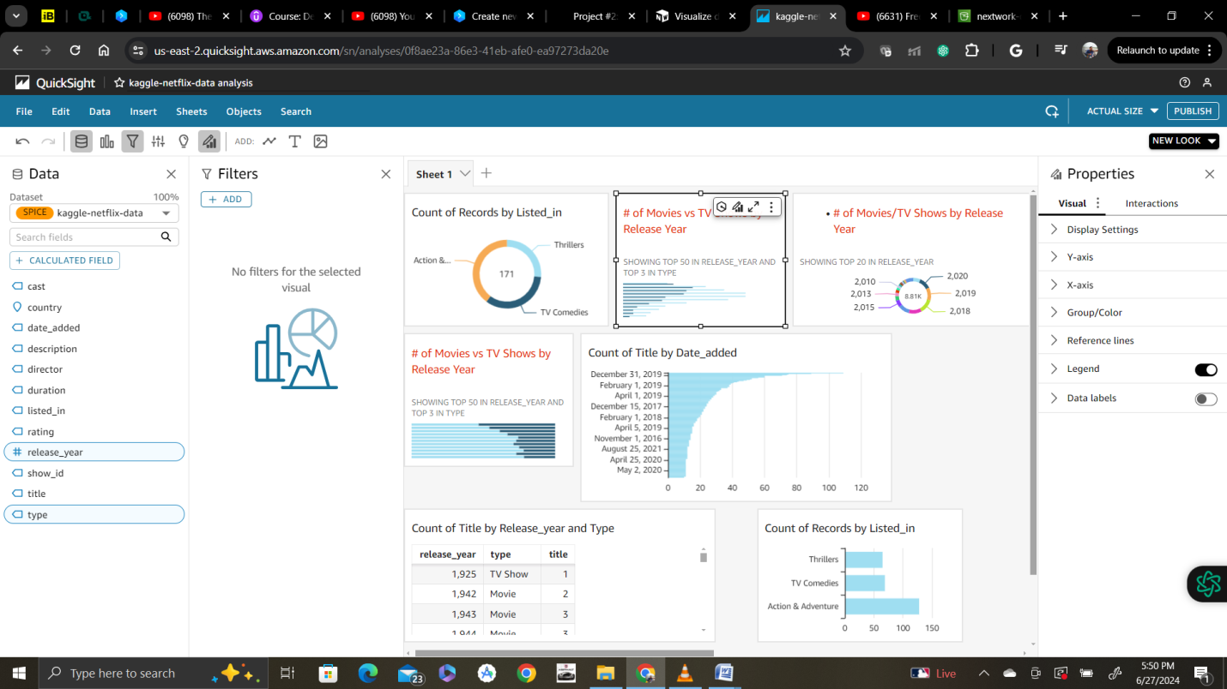

# of Thrillers, TV Comedies, Action & Adventure

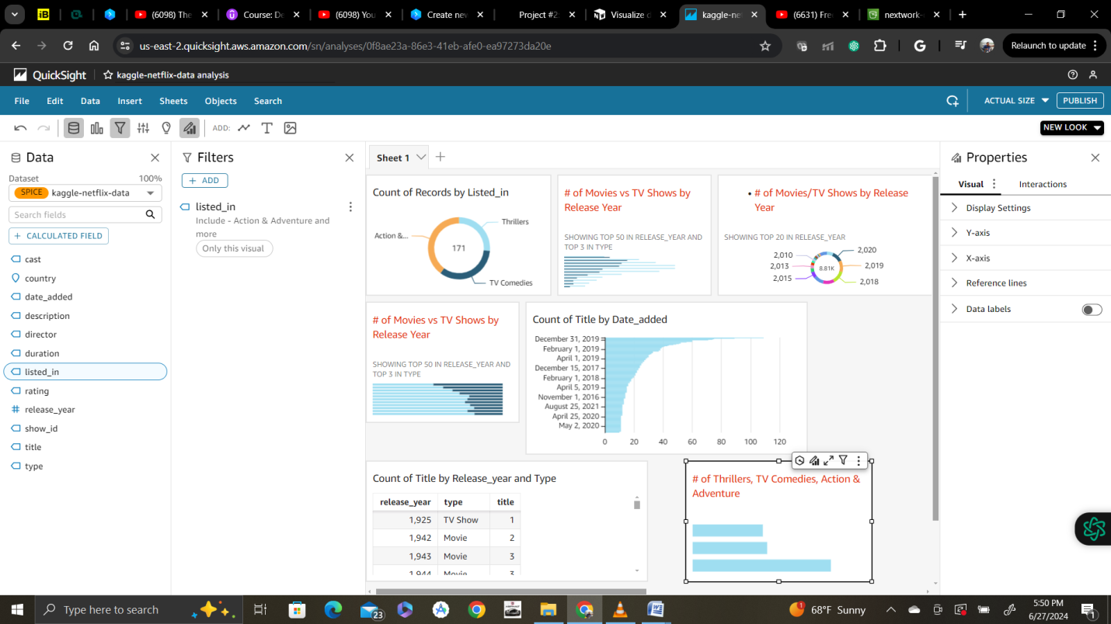

# of Thrillers, TV Comedies, Action & Adventure (released ≥ 2015)

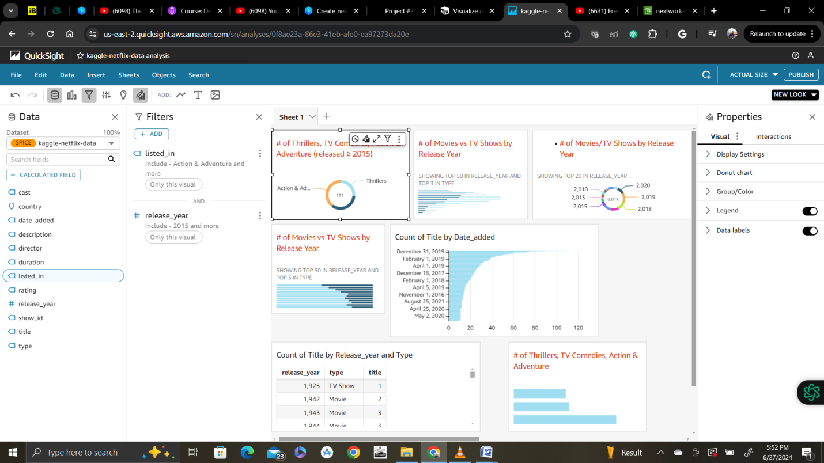

# of Titles Added by Date

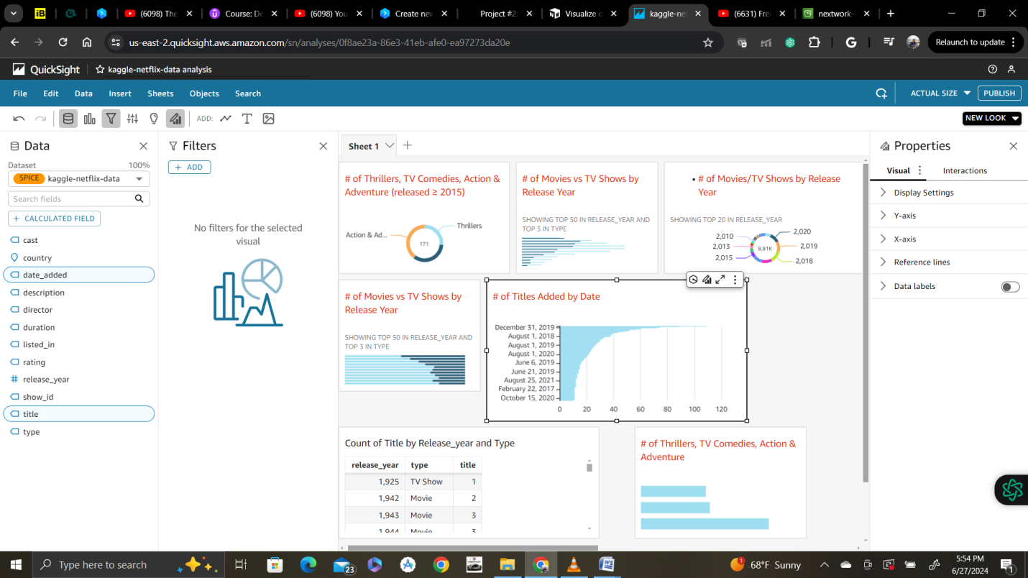

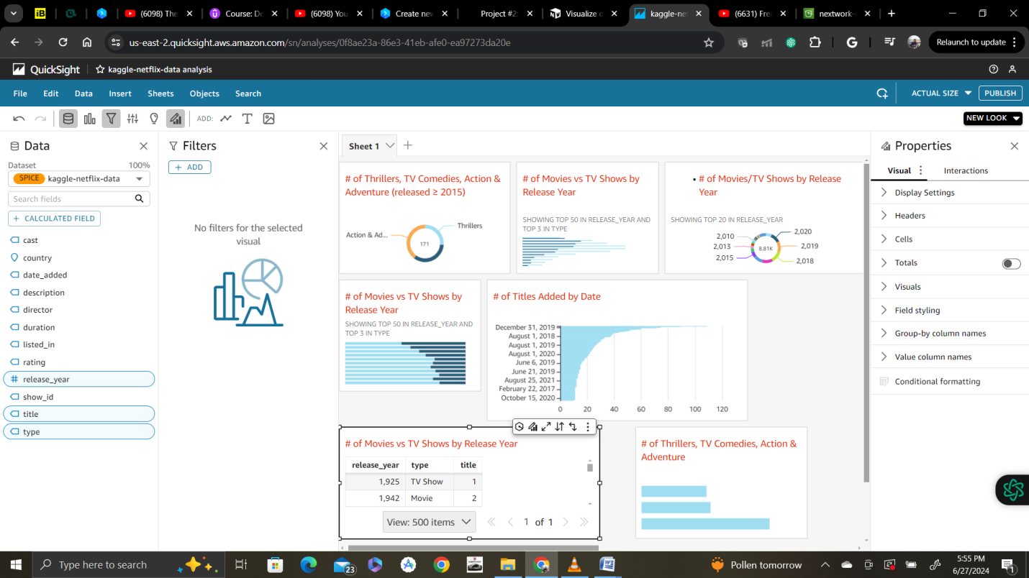

* On the top right hand corner, select Publish. This will make your dashboard public so you can share it with your data team lead.
* Give your dashboard a name (e.g. Netflix titles analysis) and click on that Publish dashboard button.

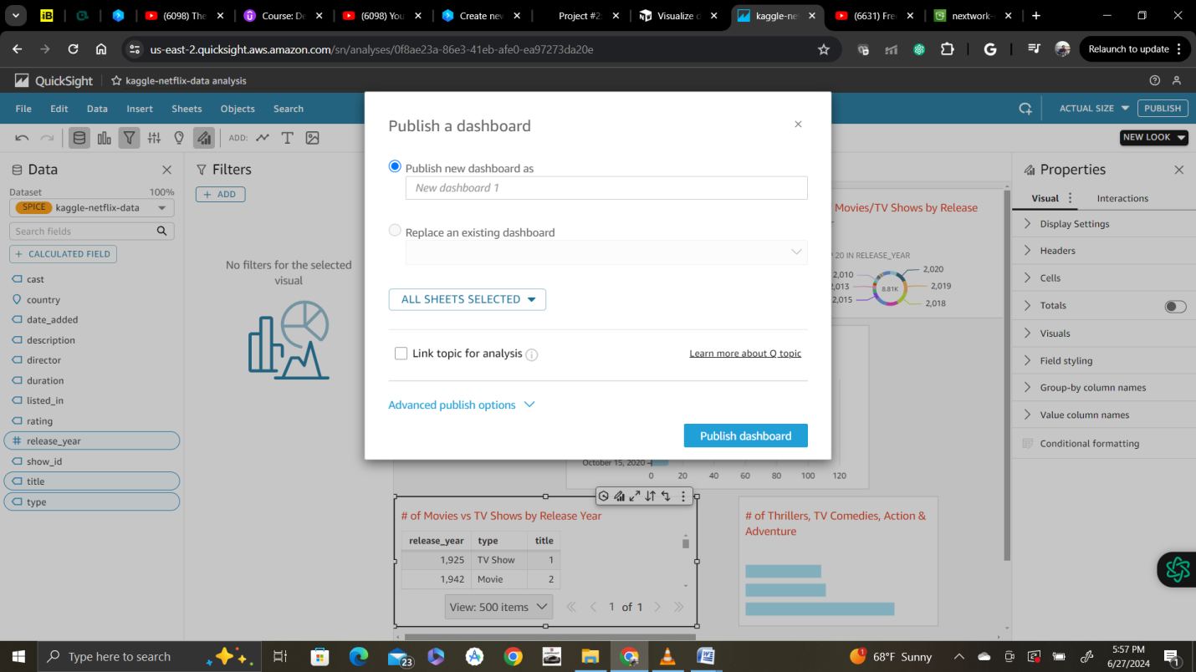

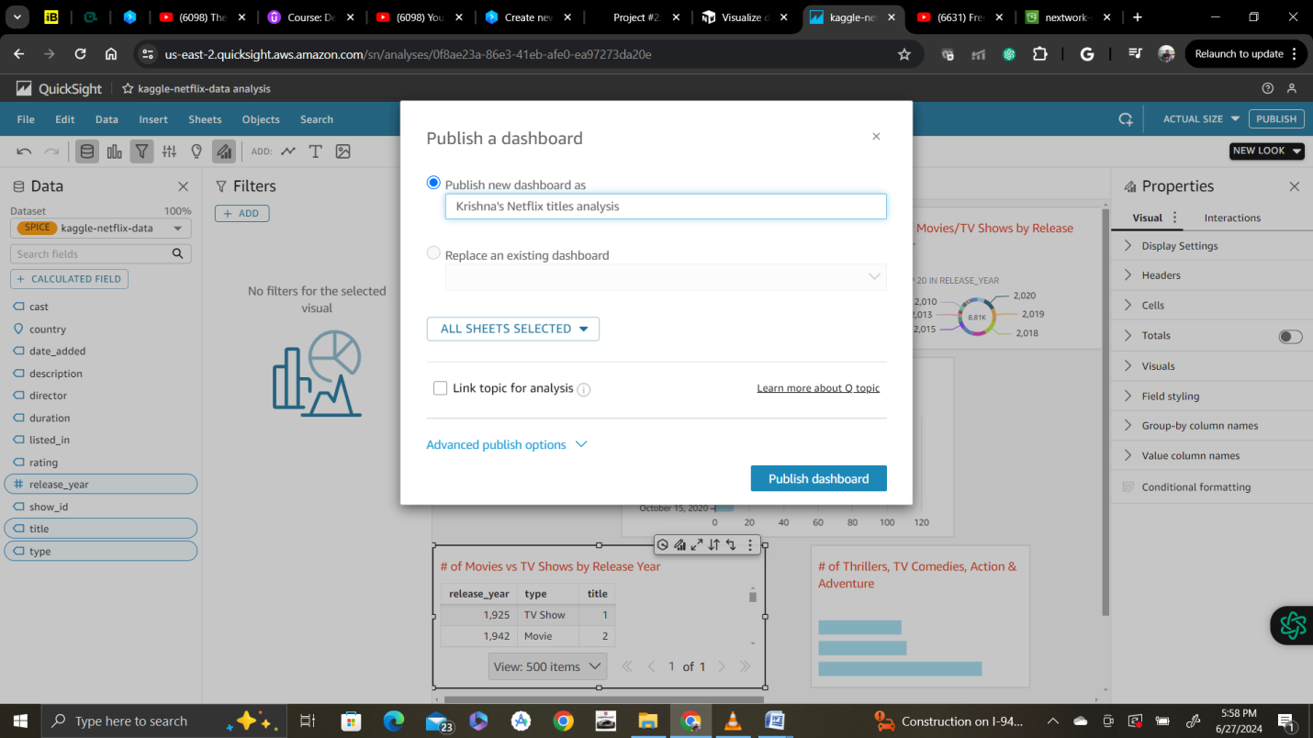

--Published.

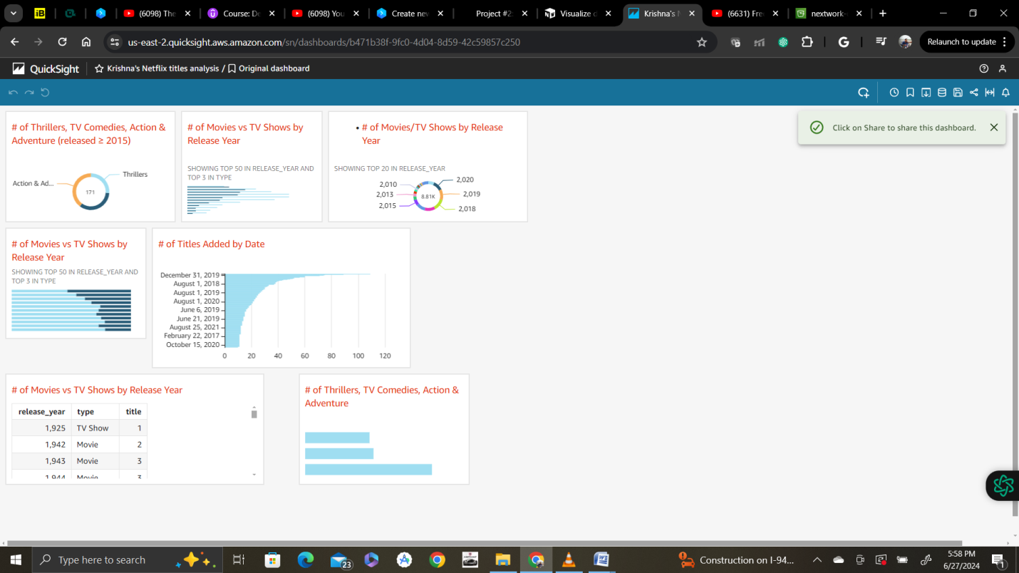

Share

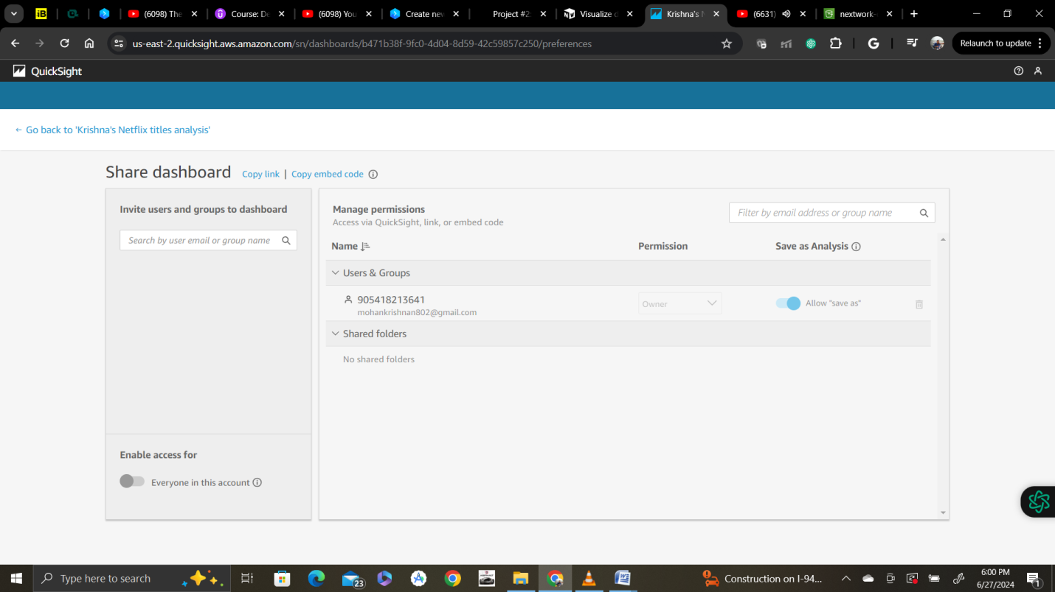

Export

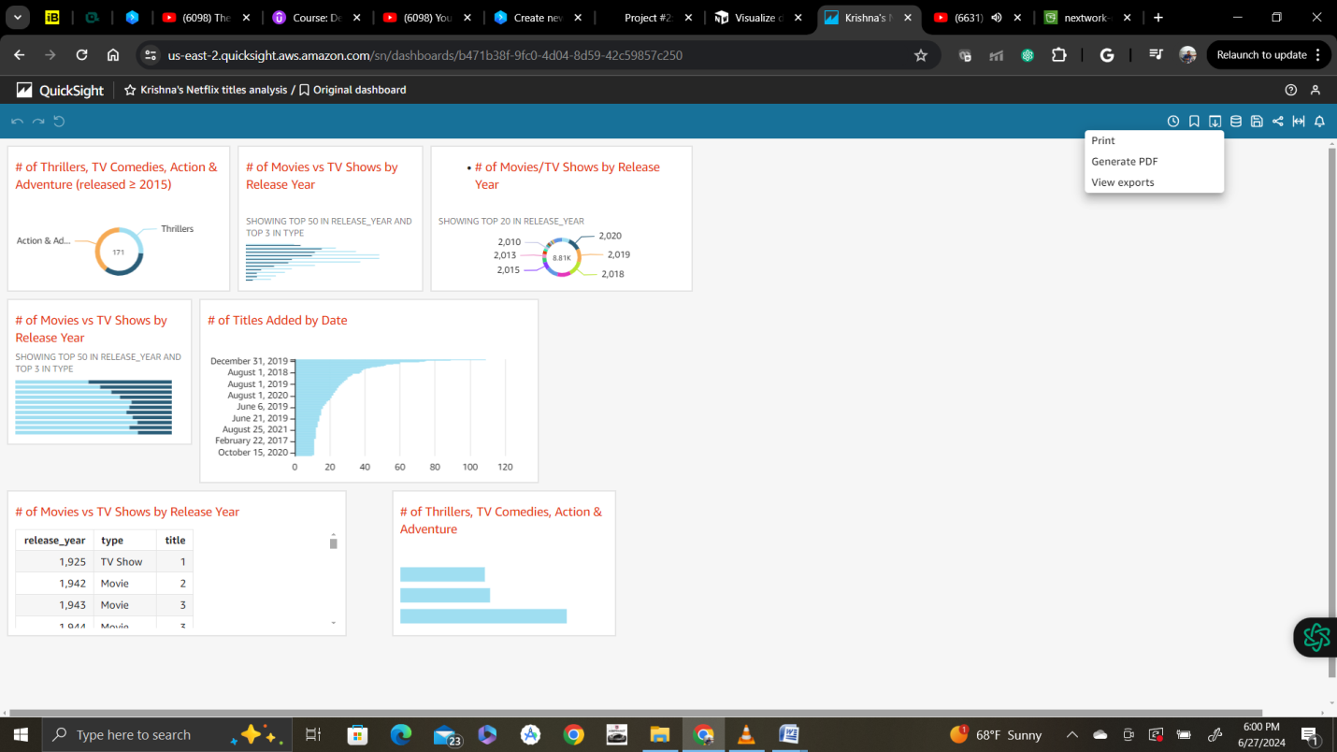

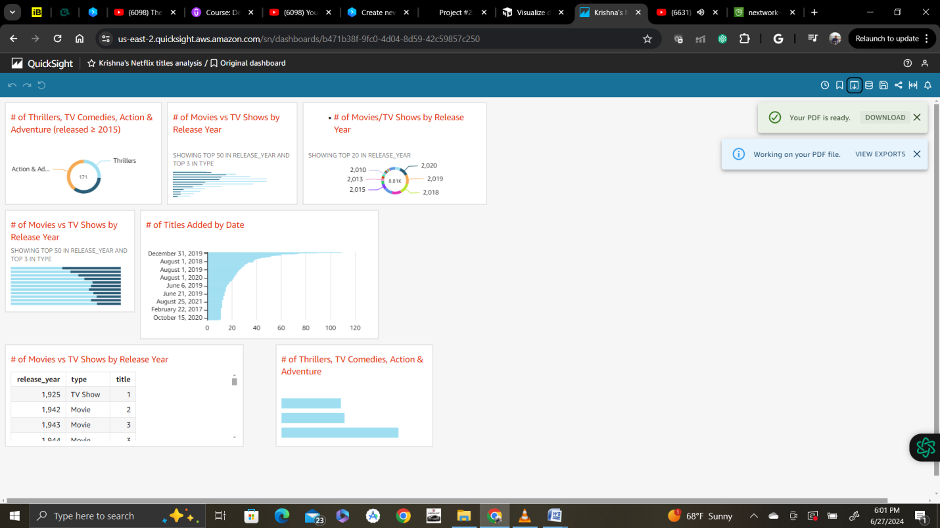

--

Downloaded pdf:

